Create a React App “counterapp” which will have a component named “CountPeople” which will have 2 methods.

UpdateEntry() → which will display the number of people who entered the mall.

UpdateExit() → which will display the number of people who exited the mall.

Use Constructor and state to Store the entrycount and exitcount.

The component has 2 buttons

1. Login → when clicked, the entrycount should get incremented by 1
2. Exit → when clicked, the exitcount should get incremented by 1

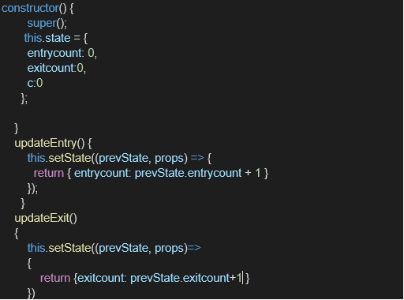

The output should be as follows:

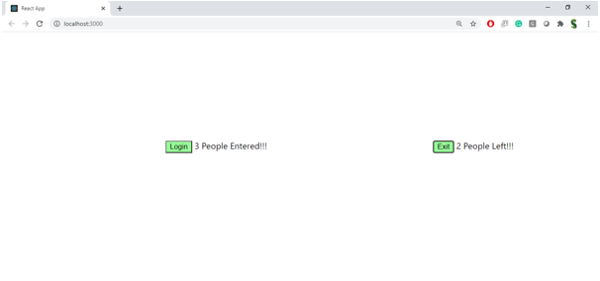

**Source Code:**

**CountPeople.js:**

import React, { Component } from 'react';

class CountPeople extends Component {

constructor(props) {

super(props);

this.state = {

entryCount: 0,

exitCount: 0

};

}

UpdateEntry = () => {

this.setState(prevState => ({

entryCount: prevState.entryCount + 1

}));

};

UpdateExit = () => {

this.setState(prevState => ({

exitCount: prevState.exitCount + 1

}));

};

render() {

return (

<div style={{ textAlign: 'center', marginTop: '50px' }}>

<h1>🧍 Mall Entry Counter</h1>

{/* Flexbox container to align everything in a row */}

<div style={{ display: 'flex', justifyContent: 'center', alignItems: 'center', gap: '30px' }}>

{/* Login button first */}

<div>

<button

onClick={this.UpdateEntry}

style={{

backgroundColor: 'green',

color: 'white',

padding: '10px 20px',

border: 'none',

borderRadius: '5px',

fontSize: '16px',

}}

>

Login

</button>

</div>

{/* People Entered count */}

<div>

<h2>People Entered: {this.state.entryCount}</h2>

</div>

{/* Exit button */}

<div>

<button

onClick={this.UpdateExit}

style={{

backgroundColor: 'green',

color: 'white',

padding: '10px 20px',

border: 'none',

borderRadius: '5px',

fontSize: '16px',

}}

>

Exit

</button>

</div>

{/* People Exited count */}

<div>

<h2>People Exited: {this.state.exitCount}</h2>

</div>

</div>

</div>

);

}

}

export default CountPeople;

**App.js:**

import React from 'react';

import './App.css';

import CountPeople from './CountPeople';

function App() {

return (

<div className="App">

<CountPeople />

</div>

);

}

export default App;

**Output:**

